Importing Multitextured Armors and Collections

Helms
- extract the helm models and textures you want to import, note if the race_gender suffixes of the models are in the old format (XXY like HuF for Human female, or the new format XX_Y like BE_M for Blood Elf Male, this will be important later).
- Note where the models point (if they are in the Objectcomponents\Head folder or in Objectcomponents\Collections folder, sometimes the people who write the community listfile like to put helms into the collections folder)

For this example I'll be using the raidduitemerald armor set and will implement it fully into the game
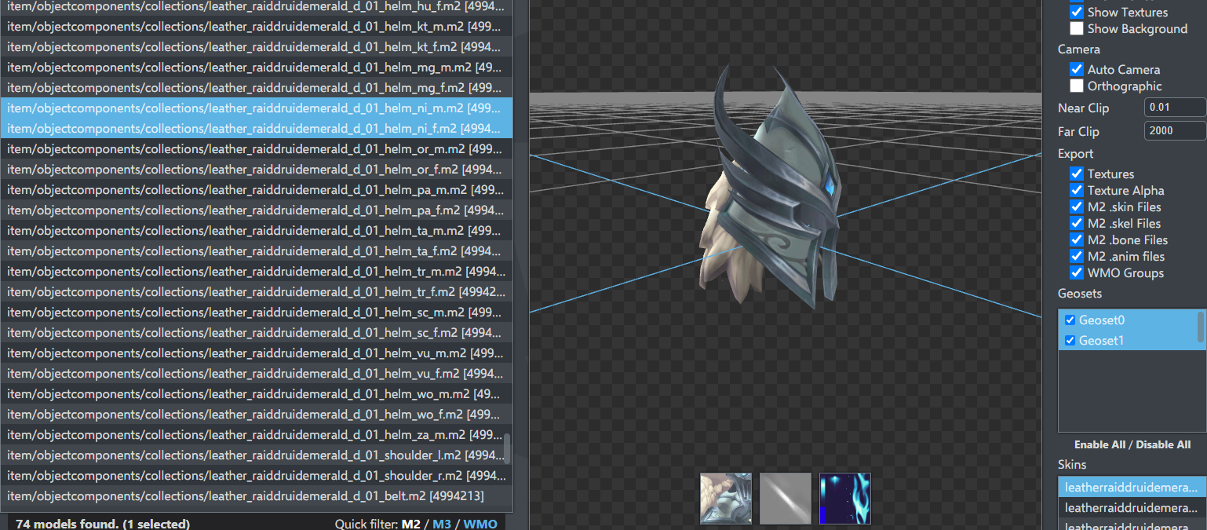
As you can see, the helm models are in the Collections folder, have the new race_gender suffix, only have skin geosets and use 2 changeable textures. (this is one ofthe easiest examples to start with)

- Open your database editor, choose a helm item to use as a base in your item_template table and duplicate it with a new Id and ItemdisplayID.
Make sure to choose a helm that correctly hides or shows the hair of your character depending on what you want.
Since they are relatively similar, for this example I'll be using the Stormrage T2 set as a base for my import.

- Do the same with the same Item ID on your Item.dbc and for the corresponding ItemDisplayId for the ItemDisplayInfo.dbc
in the itemdisplayinfo fill in the Model_1 and Texture_1 column with the helm model stripped of the suffixes and the base texture.

Now look at the Icon_2 column, here is wheresome of the magic comes into play.

Here you can choose the attachment point for the model in Model_1 and Model_2, the flags you want the module to use for working on the model and the folder where the model resides, all separated by : .
Now, this is a normal helm model, so the first attachment point, leave it empty, there is no second model loaded, so leave the second model attachment empty.
Since your model is using the new race_gender suffix and you don't want to hide geosets, just leave this part empty.
Lastly, since your model resides into the Collections folder, put Collections there.

In the end, the entry for Icon_2 will be:

:::Collections

Now if the helm just had the base texture, you would be done, but since there is an extra texture involved, you have to go on declaring things for this helm.

- Since there is only one model to render here, you can skip Open WXLItemDisplayModels.csv and directly open WXLItemDisplayModelMaterials.csv

- Start making lines to declare the textures for your helm model:
DisplayId, 0 (first model in the column), ModelName_1 (column model 1), Model name without race_gender suffix, Texture Type (this item has Texture Type 2 and 3, so you have to make a line for each), folder where the model is (Collections), Texture you want to use for the texture type, keep SkinMapOnly

- Now copy your item.dbc and ItemDisplayInfo.dbc into your server and try the item.
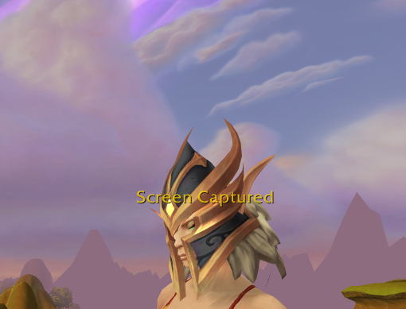
Shoulders

Shoulders are the next step in difficulty since they have 2 models (generally) Left and Right.
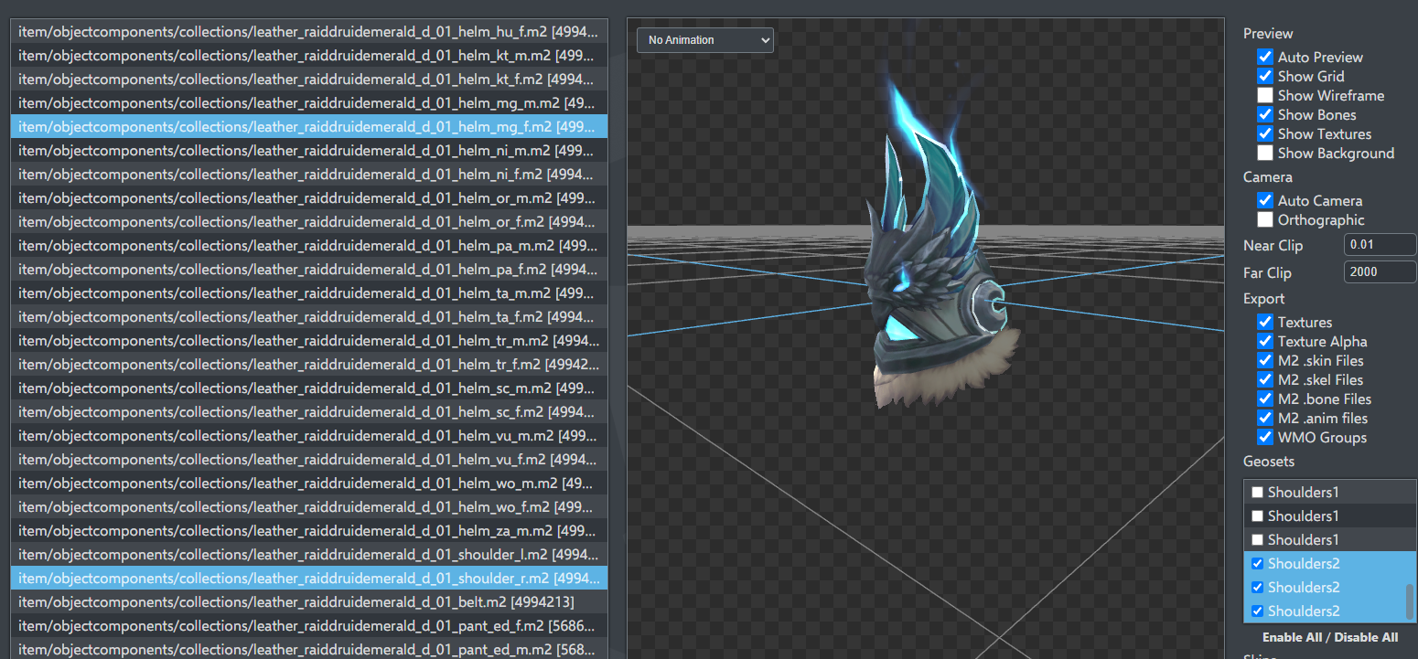
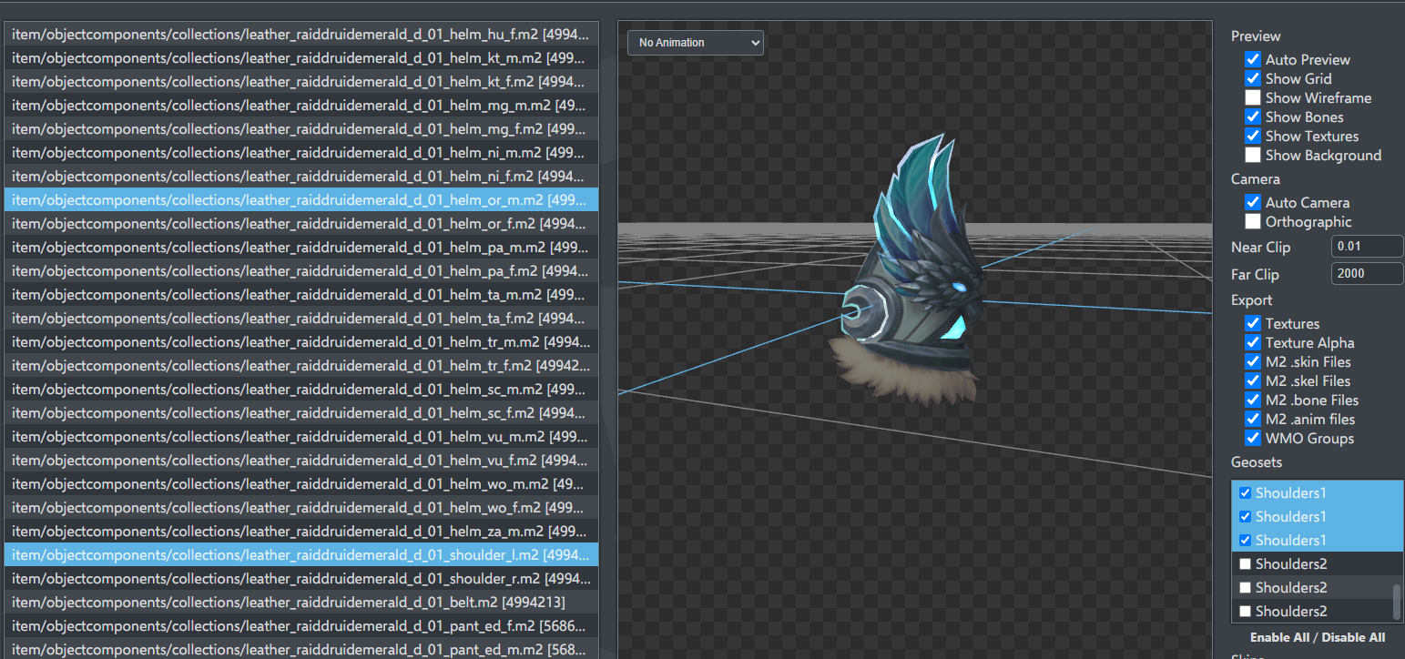
Note also that these two shoulders have different sets of shoulder geosets (these were used to distinguish between the regular and mythic variants of the item, I will filter the normal one for the left shoulder and the mythic one for the right soulder.

As you already know how to do, make a new item, with a new Item ID and Display ID both in the database and Item.dbc and then make the new row in ItemDisplayInfo.dbc

We will start right at the ItemDisplayInfo.dbc

Notice that in the Model_1, after the name of the model there is :2601 and in Model_2 after the name of the model there is :2602
This means that the models will be filtered based on the 2601 (Shoulder1) and 2602 (Shoulder2) geosets respectively.

In Icon_2 we have 6:5:6:Collections
Which meand: Model_1 is attached at attachment point 6 (Left Shoulder), Model_2 is attached at attachment point 5 (Right Shoulder), 6 special flag to remove gender and race suffixes, Models are in the Collections Folder.

Now we have to Declare the models into WXLItemDisplayModels.csv

DisplayID, leave ItemID empty, Shoulder slot, Base Layer, Sides L for Left, R for Right C for center, Shoulder folder, Model, texture, geosets you want to show (if multiple use “xxxx,yyyy”), attachment point, then DBC and Exact are ok unless you want to change things.

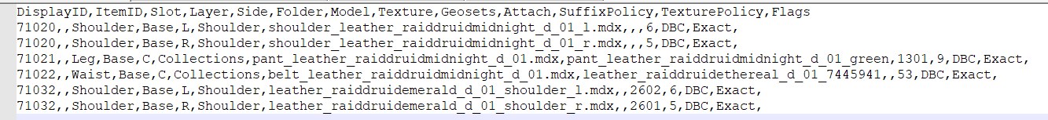

Open WXLItemDisplayModelMaterials.csv and add for each of the two models the required textures

Copy the item.dbc and itemdisplayinfo.dbc in the server and try the item

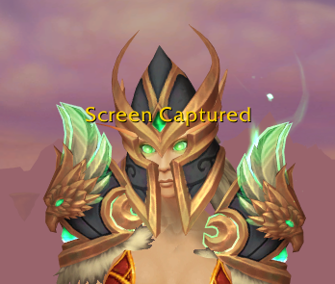
Notice how one shoulder item has the extra glow (from the mythic version of the 2602 geoset) and the other does not (base 2601 geoset).

